Dan Baker
Construction Management
Faculty Advisor: Dr. Riley
Bed Bath & Beyond/
Christmas Tree Shops
300 Ikea Drive
Paramus, New Jersey

Existing Conditions

Table of Contents
A. Executive Summary………. ...……………………………………….. 2
B. Project Scedule ……………………………………………………….. 3,4
C. Building System summary …………………………………………….5,6
D. Project Cost Evaluation ……………………….…………………….... 7-10

Executive Summary

This project has proven to have many interesting features and their impact on the project is continually being analyzed. The uniqueness of starting the project part way through construction when things have gone off course and making an effort to meet the needs of the owner cause many difficult decisions and careful planning. This assignment will help further look into the setting and scenario in which the project is being constructed and how this may have impacted the cost and schedule of the project. Looking at how a project is effected by mid project management switches and how the cost of a project is effected by last minute changes are just some of the items to be addressed in the future research.

Project Schedule

Foundation
The site was built on an empty lot in a retail development area. Prior to the construction of the foundation there was much site work to do. Loading docks and screen walls were backfilled and truck and transformer pads were graded. Excavation for the space was done and utilities were needed for the location including: sewer, domestic water lines, storm water piping, and electrical. Trenching was done to run these lines to the building location. Prior to the slab on grade being poured there was some large cast in place stairwell towers to be placed via crane as well as foundation piles. The slab was poured shortly after steel erection began for the structure.

Structural
Steel was erected with the crane as soon as construction went on its way. Steel beams and columns were placed as the main structural element of the building and concrete slabs were poured for each floor on top of the metal decking. Although the vast majority of the building was done with steel frame structures, there was an existing parking deck that needed to be altered due to changes to the building. Late in design it was determined that the building needed to be raised four feet to allow for the clearance of fire trucks through the ground level parking facility. This caused the buildings third floor to be higher then the parking structure north of it, when they were intended to be the same height. A ramp was required to provide access which lead to the design of a garden and pond to go on the roof to fill the height difference. Due to the additional weight of the garden items portions of the precast parking garage were removed and replaced with a cast in place concrete support. This added some difficulty to the project and a substantial cost increase.

Finishes
Finishes throughout the building were phased between the Christmas Tree Shops on the third floor and the Bed Bath & Beyond on the second. This allows the use of the same subcontractors for the building without requiring them to split their resources between the 2 finished stores. Starting with Bed Bath & Beyond the finish trades were staggered by approximately a week. This spreads out the subcontractors throughout the project and provides a better flow of subcontractors.

Building System Summary

Architectural
This project offered some unique situations which in return offered some unique architectural responses. The greatest example of this is the rooftop garden on top of the adjacent parking structure. There was an existing 3 story parking garage that was supposed to be the same height as the Christmas Tree Shop on the 3rd floor of the project, however the need to raise the building for fire truck clearance caused a difference in their heights. The architectural response to this was to fill the space with a ramp to provide access and a rooftop garden with a water feature. As well as unique features such as this, the building has high quality construction throughout the space. The building contains a large entry vestibule, ground level parking decks, vertical transporation, a vast retail space for two different stores, sales areas, and many private sections for employees and company members to work in. The building reflects high standards of architecture and requires a high quality of construction.

Demolition
Due to the project being on an empty lot the only demolition required was to remove an existing precast concrete structure in the adjacent parking garage to the north of the building so that it could be replaced with a more structurally sound support. There was also minor demolition to the garage to provide for bridging between the garage and the new Bed Bath & Beyond/ Christmas Tree Shops.

Structural Steel
The structural integrity of the building is provided by a steel structure frame. This was built by a different general contractor prior to Schimenti Constructions involvement. It was done with multiple cranes. Columns, beams and girders provide the frame along with metal decking to pour the slabs.

Concrete
Concrete was used for the slab on grade and 2nd and 3rd floor slabs. Prior to the pouring of the slab the large stairwell towers were formed and cast in place using the cranes. Due to the additional weight of the rooftop garden and pond there was the need for additional cast in place structures in the parking garage below it. Sidewalks were cast throughout the perimeter of the building and additionally concrete columns were used for support.

Masonry and EIFS
The exterior is a combination between simulated stone and EIFS finishings. CMU block with a brick veneer is used on some of the exterior and the stucco is used on the remainder. These walls are primarily for veneer purpose not load bearing. There is a unique curved masonry feature at the entrance way.

Mechanical
The building contains a wet pipe sprinkler system throughout its entirety supplied by a water riser. Copper domestic and sanitary plumbing lines are used along with steel gas lines. 18 rooftop units provide for the HVAC system that have exhaust ranging from 200 CFM to 10,000 CFM of air. A variety of different ducts sizes are used in distribution of forced air. The HVAC is run constantly during occupied hours and by demand during unoccupied hours. These settings are coordinated with the NOVAR control system to be installed. All ducts have smoke detectors for fire alarms. Mechanical room is in the South West corner of the building.

Electrical
The building is run off 13 electrical panels 3 with voltage 277/480 and the remainder at 120/208. They supply the constant lighting to the sales area and an unoccupied night lighting sequence controlled by the automated control system. Specialty lighting for the exterior is supplied for items such as external lights and signage lighting. Lighting is run both behind the drywall and in slabs to locations such as mid floor cash-wraps for the (POS), point of sale system. Fire alarm systems are throughout the store and both audio and visual alarms are generously used in all areas. The electrical room is in the South West corner of the building.

Project Cost Evaluation

Building Construction Costs

The buildings initial budget was $25,439,012.00 including all costs such as overhead, profit and site work. Removing the site work and profit costs from the budget the approximate new budget was $24 million. The building including the 2 retail space floors and the parking level is 170,866 SF.

Building Construction Cost:
CC/SF = $140.46/SF

Total Construction Cost:
TC/SF = $148.85/SF

-Steel Cost: $16.15/SF
-Concrete Cost: $15.00/SF

-Finishes Cost: $20.48/SF

-Plumbing Cost: $2.33/SF
-Sprinkler Cost: $1.79/SF
-HVAC Cost: $6.13/SF

-Electrical Cost: $16.56/SF

D4 Cost Estimate

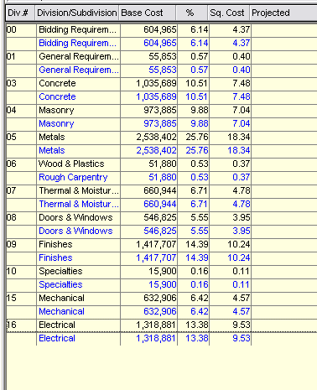

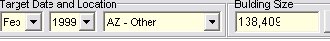

Total Cost: $11,071,225
Cost per square foot: $79.99/SF
*Scottsdale, Arizona
*Construction Period Nov 99 to Jan 01
*Negotiated Bid Date Feb 99

R.S. Means Estimate

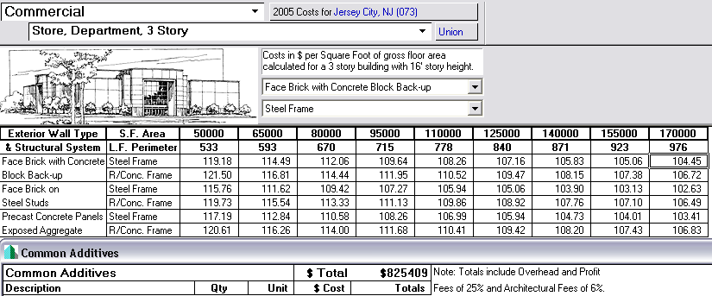

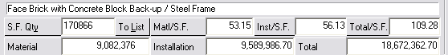

Total Cost: $18,672,362.70
Cost per square foot: $109.28/SF
*Jersey City, New Jersey
*Construction Period 2005

I made the assumption that Jersey City, NJ due to the proximity to Paramus, NJ would provide more accurate location factors then the national average. The closest building type to compare to my project is a 3 Story department store, rather then a 1 story parking garage with 2 stories of stores above it. I put additives into the project to help compensate for some of the features of the Bed Bath & Beyond/ Christmas Tree Shops building. I added conveying systems such as elevators, and sound systems such as amplifiers and speakers. I believed this would give a more realistic representation of my project.

Cost Comparisons

I think there are some very straight forward reasons why the cost per square foot of the projects comes out different. Starting with D4’s estimate, the database couldn’t provide a project similar to mine. There were very few retail projects listed and the few that they had were much smaller and of a different scope of work. I considered using a 1 story 25,000 SF staples building but I don’t believe that was comparable to my building. I selected a retail shopping center of a similar scale square footage wise; however the entire project was 1 story high and didn’t have many of the challenges the Bed Bath & Beyond has. The projects cost was significantly lower and this is likely due to the lack of similarities in the project scope and type and also the setting in which it was built. The project took place 6 years prior and in Arizona. Both of these factors would cause the cost to be significantly cheaper. Other areas of large differences in price occurred between mechanical and finish costs, where D4 underestimated in these areas.
Comparing the R.S. Means estimate to the actual cost provides more logical results. The price was still lower, but much closer to the actual cost of the building. CostWorks allowed for alterations to the project based on location and year, this eliminates that factor on the price. I also added the proper amount of conveying systems to make the projects more similar, however the actual conveying systems cost was over $1.3 million while R.S. Means only added $825,409 for all the additives including audio equipment. Again the project type was also different as R.S. Means estimated for a 3 story department story not a 2 story with a parking garage beneath. If the actual project was slightly less complex then it was I believe the estimates would have been more similar.

